Health check script dev_hcv2.5.6.py now supports **Non Root** login as well as standard **Root** login. Please follow below steps

1. Provide the script directory path (can be different ) in **SCRIPT_DIR**



**Make sure the dir has the user login permissions if you are using Non Root login**

1. Set these Global parameters, see screenshots, as per the deployment

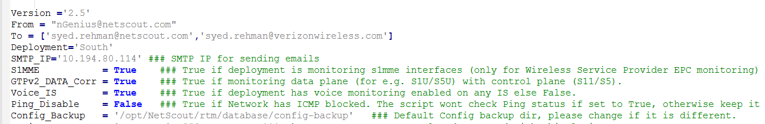

1. Set the user login



If you are using root give **‘root’** as Login.

1. Make sure the SSH trusts are created for root or non-root logins between all the boxes (IS and PM) and the Jump box ( where the script resides)
2. Login from **Non-Root** or **Root** login on the jump box
3. Create a Public Key on the box:-

**ssh-keygen**

Generating public/private rsa key pair.

Enter file in which to save the key (/root/.ssh/id_rsa):

Enter passphrase (empty for no passphrase):

Enter same passphrase again:

Your identification has been saved in /root/.ssh/id_rsa.

Your public key has been saved in /root/.ssh/id_rsa.pub.

The key fingerprint is:

a8:98:48:e1:1a:6d:60:02:75:3a:34:41:f9:70:9a:da root@jumpBox01.localdomain

The key's randomart image is:

+--[ RSA 2048]----+

|.o*o. |

|..o+. |

|ooo* |

|+o+.. . |

|.=o . S |

|++Eo . |

|o o . |

| |

| |

+-----------------+

1. Copy the public key to remote-host using ssh-copy-id:-

**Root login :- ssh-copy-id -i ~/.ssh/id_rsa.pub 10.0.0.1**

**Non-Root login (for e.g. netscout):- ssh-copy-id -i /home/netscout/.ssh/id_rsa.pub 10.0.0.1**

The authenticity of host 10.0.0.1 (10.0.0.1)' can't be established.

RSA key fingerprint is 85:67:f5:14:ed:17:01:3e:7f:20:65:b8:e9:f6:86:61.

Are you sure you want to continue connecting (yes/no)? yes

Warning: Permanently added '10.0.0.1 (RSA) to the list of known hosts.

root@10.0.0.1password:

Now try logging into the machine, with "ssh '10.0.0.1’", and check in:

.ssh/authorized_keys

to make sure we haven't added extra keys that you weren't expecting.

1. SSH the IP to verify that no password is required and trust has been established:-

ssh **10.0.0.1**

1. Health Check script dev_hcv2.5.6.py runs as follows

**./dev_hc_v2.5.6.py -f <PMs IP file> -i < IS IP file> -l Yes/No -s <email subject>**

1. **PM IP file** should have following format:- (IP, Global/Local PM indicator)

10.193.79.140,GPM

10.193.141.193,GPM

10.193.141.192,Local_PM

10.193.86.6,Stdby_PM

GPM indicates Global/Global standby PM and Local_PM indicates Local PM and Stdby_PM is standby PM. Please make sure that there should not be any empty line between or at the end of the file. Otherwise script will display wrong count on the email body.

1. **IS IP file** should have the following format :- (only IPs)

10.213.133.64

10.213.133.65

10.213.133.66

10.213.133.67

Please make sure that there should not be any empty line between or at the end of the file. Otherwise script will display wrong count on the email body.

1. Option ‘l’ is the option for checking link status summary report. Select ‘Yes’ for the script to generate the link status summary report otherwise ‘No’

**./dev_hc_v2.5.6.py -f <PMs IP file> -i < IS IP file> -l Yes/No -s <email subject>**

If –l is selected Yes ,it will generate link status output in html

1. Install the cronjob to get the automated output daily.

Run **crontab –e**

and install the script for e.g. (modify it as per your configuration)

00 7 * * * /opt/scripts/NE_dev_hc/dev_hc_v2.5.6.py -f /opt/scripts/NE_dev_hc/dev_pm2 -i /opt/scripts/NE_dev_hc/dev_is.txt -l Yes -s " North-East PM IS Health-Checks and Link Reports `date`"

Run :wq to save the cronjob